Fruit Tree

# Fuji Apple Tree

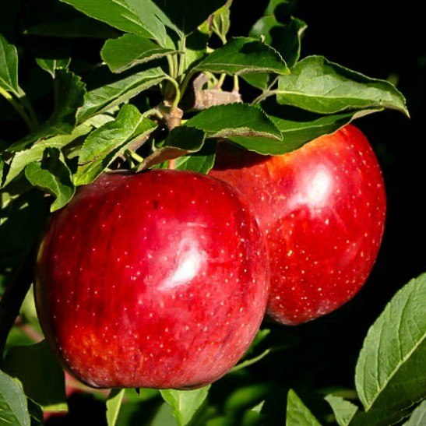

**Price:** $130.50

**Max height of mature tree**: 10 ~ 15 ft

**Growth Rate**:

**Description:**

The Fuji Apple Tree is a wonderful, sweet apple that is widely grown for its attractive red color on a green background and for its sweet, crunchy texture and good flavor. It has an attractive appearance, with red and pink coloring on a green background, and white flesh. It is an excellent apple to grow in the central parts of America which are not too hot or too cold. If you are looking for a familiar, popular apple to grow and enjoy straight from the tree and one that is sweet and loved by children, then Fuji is a terrific choice.

**Conditions of Place to be planted:**

* Sun: Full Sun
* Drainage: Best in well-drained soil that does not become too dry.

**Maintenance Requirements:**

Apple trees need pruning and training from the beginning of their life with you. Plan to develop a tree with a central stem and side branches radiating out almost horizontally. Use string tied to stones to pull the branches down while they are young. Upright branches can easily break when the trees are older and your tree will be damaged, so start training early. It only takes a little time. Older trees should be trimmed to control their height.

# Wonderful Pomegranate

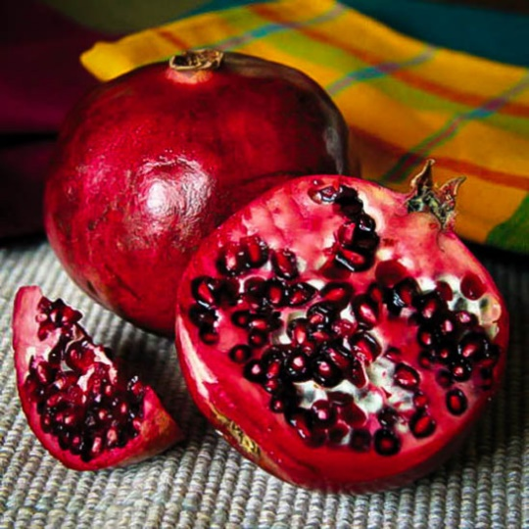

**Price:** $140.50

**Max height of mature tree**: 15 ~ 20 ft

**Growth Rate**:

**Description:**

The Wonderful Pomegranate is a small tree from 15 to 25 feet tall that thrives in hot, dry conditions and can be grown anywhere winter temperatures are above 100F. It will grow in most soils and established trees need no additional watering or special care, so this is an excellent low-maintenance tree for warmer states. It can be grown as a specimen or planted in a row as a barrier or a hedge. The fruits ripen in early winter and can be used for juice, eaten fresh or as an addition to salads of all kinds. They are a popular ingredient in Middle Eastern cooking.

**Conditions of Place to be planted:**

* Sun: Full Sun
* Drainage: Well-Drained

**Maintenance Requirements:**

A single tree should be given at least 10 feet of room from buildings or other plants. For a screen space the trees 6 feet apart and for a hedge 3 or 4 feet apart. A hedge should be clipped once a year only, immediately after the fruits have been picked. More frequent clipping will reduce flowering and fruit production.

Evergreen Trees

# Little Giant Arborvitae

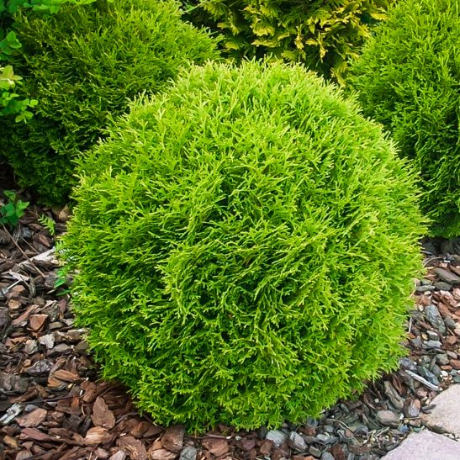

**Price:** $108.50

**Max height of mature tree**: 2 ~ 4 ft

**Growth Rate**:

**Description:**

The Little Giant Arborvitae is the perfect plant if you want a round green ball, of medium size, without needing to clip or trim it. It grows steadily into a near-perfect sphere 2 feet tall and wide, ultimately reaching about 4 feet in both directions. It stays green all year round, without winter bronzing or burning, and it is incredibly hardy, all the way through zone 4. It grows well in warmer areas too, up to and including zone 7. Grow it as part of the foundation planting around your home, in the front of beds for accents, or in rows or groups for a formal look. It fits perfectly into planters and pots, giving that neat, round look, but needing no clipping at all.

**Conditions of Place to be planted:**

* Sun: Full Sun to partial shade
* Drainage: Any soil; moderate - drainage

**Maintenance Requirements:**

The Little Giant Arborvitae is **incredibly hardy**. Even in chilly zone 3, which is found straddling the border with the US and Canada, this plant thrives. Yet it is tough enough to do well as far south as zone 7 too, where it is just as useful for its neat, round form. Soil is not a problem either, because this bush will grow in almost any soil, sand or clay, as long as it doesn’t sit wet for weeks at a time. It is, however, **much more tolerant of wet soils than most other conifers**, as is obvious when you see it growing wild in wet-land areas. Pests and diseases are not a problem, although deer will graze on it in winter, given a chance. Clipping is strictly optional, and some gardeners do like to clip once a year, just to get a geometrically precise look, but for most of us, this shrub’s natural roundness is just fine.

# Thuja Green Giant

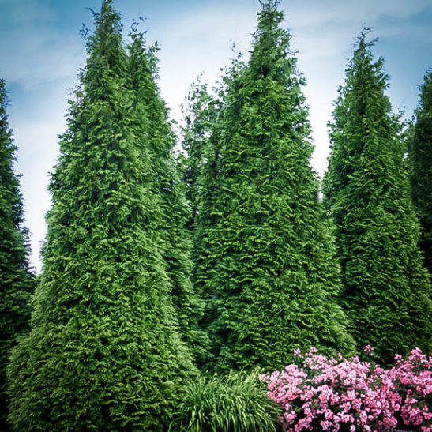

**Price:** $229.50

**Max height of mature tree**: 20 ~ 40 ft

* **Growth Rate**: **Extremely fast growth-rate – 3 to 5 feet a year**

**Description:**

when you need a large screen or wind-break, Thuja Green Giant is the perfect choice, with its exceptional rate of growth, its toughness under all conditions and the speed with which it easily reaches full-size in a short time. It is always a perfect rich green and so beautiful it has to be the number-one choice for a large hedge. planters and pots, giving that neat, round look, but needing no clipping at all.

**Conditions of Place to be planted:**

* Sun: Full Sun to partial shade
* Drainage: Adaptable

**Maintenance Requirements:**

If the weather is warm and dry, water your Arborvitae Green Giant twice a week for the first month after planting and then once a week until late fall. If the weather is cooler, you can water just once a week right from the start. For the first few years you will get maximum growth by watering regularly, especially during warm or dry weather. For a hedge, putting a drip line or trickle hose in place will make this easy to do, and give you the best growth.

Hedge

# California Privet

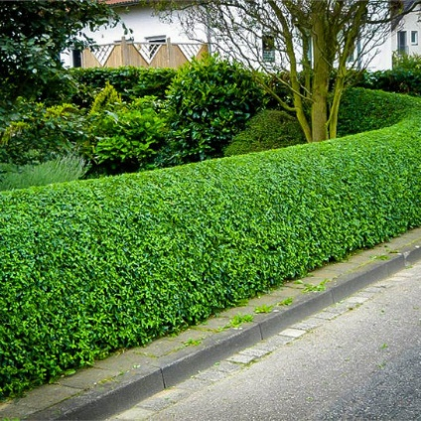

**Price:** $150.50 for 3 Gallon

**Max height of mature tree**: 10 ~ 15 ft

* **Growth Rate**:

**Description:**

There is always a need for a tough plant for those tough spots that are found in most gardens. Underneath large, established trees; in a hot, dry area; where you need evergreen screening in a hurry; or where you want an easy, low-maintenance plant in a harsh urban situation. California Privet is the answer to all these problems, and more.

**Conditions of Place to be planted:**

* Sun: Full Sun to partial shade
* Drainage: Ordinary well-drained soil

**Maintenance Requirements:**

Choose a sunny or shady spot for your California Privet. The great thing about this plant is that **it will grow almost anywhere, under the harshest conditions**, although it is not tolerant of constantly wet soil. Young plants will benefit from some fertilizer, but really this is a plant you can just put in and leave alone – ideal for the busy gardener. California Privet is free of any significant pests or diseases and very tolerant of drought.

# Vinca Minor “Bowles” Periwinkle

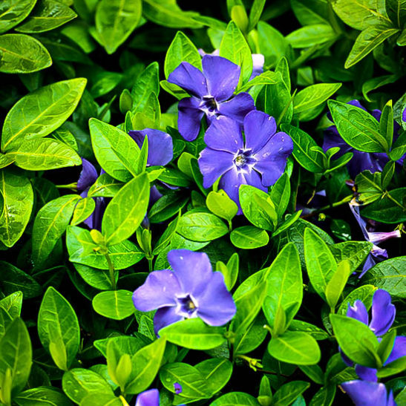

**Price:** $109.50 for 1 Gallon

**Max height of mature tree**: 4 ~ 12 inches

* **Growth Rate**:

**Description:**

Bowles Periwinkle is the ultimate ground-cover plant. Evergreen, with small glossy leaves of a rich, dark green, this plant thrives and spreads in all the shady parts of your garden. It turns boring, brown areas into a beautiful green carpet, smothered in spring with rich blue flowers.

**Conditions of Place to be planted:**

* Sun: Full shade to partial shade
* Drainage: Average to moist soil

**Maintenance Requirements:**

In a season or two they will grow together to form a continuous, weed-proof mat. If your plants spread into areas where you don’t want it, it is easy to trim back with a sharp spade, and remove the shallow-rooting unwanted growth. In fall, the leaves of the trees above will mostly fall inside the plants, reducing the raking or blowing you need to do. Do check in late fall, and remove any leaves that have completely buried the plants, as these will reduce growth.

Palm Tree

# Pygmy Date Palm

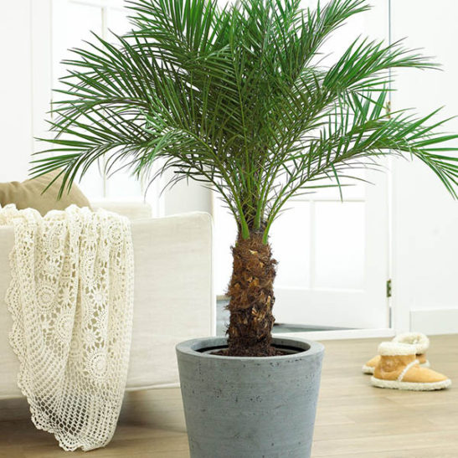

**Price:** $100.50 for 3 Gallon

**Max height of mature tree**: 6 ~ 10 ft

* **Growth Rate**:

**Description:**

The Pygmy Date Palm is truly one of the most beautiful palm trees available, and it has the great advantages of remaining small, and of growing in lower light than most other palms. Bigger palms become too large for most home, and need a lot of light, but the Dwarf Date Palm never outgrows its welcome, and it will thrive indoors for decades. Place it in moderate light, water when dry, fertilize from time to time, and it will be happy. It has the classic ‘palm tree’ look, with a rough brown trunk and circular crown or arching leaves, each with a central stem and many slender side leaflets. This palm tree fits into any kind of room, from classic antiques to ultra-modern, and everything in-between.

**Conditions of Place to be planted:**

* Sun: Sun or Shade
* Drainage: Average

**Maintenance Requirements:**

Outdoors it will grow in **sun or partial shade**, and in shade it will benefit in winter from the protection of trees overhead. It will grow in most soils, as long as they are well-drained, and once well-established it is drought-resistant. Use a palm fertilizer which will have a large last number (for Potassium), such as 8-2-12. The fertilizer should also have supplementary Iron (Fe) and Magnesium (Mg).

# King Sango Palm

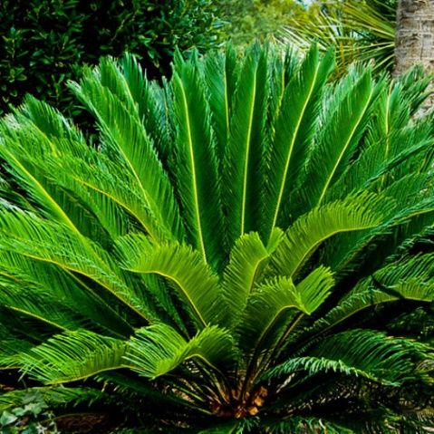

**Price:** $120.50 for 3 Gallon

**Max height of mature tree**: 3 ~ 8 ft

* **Growth Rate**:

**Description:**

The Sago Palm is a unique and beautiful plant that will grace any warmer garden, or it can be grown in a container and enjoyed in cooler gardens too. It is not really a palm tree, but it has a similar thick, hairy trunk and a rosette of feathery leaves at the top, indeed looking similar to a small palm tree. It is hardy in zone 7 and everywhere warmer, and can even take a little snow without damage. This beautiful plant will grow slowly into a small tree several feet tall, and eventually much taller, and will in time produce side plants, making a gorgeous clump that is an elegant feature in any garden. The leaves are like a bird’s feather, with stiff, thin and shiny leaflets growing of a central stem. They radiate from the top of the trunk in a symmetrical circle and resemble an elegant and special palm, although this plant is more closely related to a spruce tree than to a palm tree.

**Conditions of Place to be planted:**

* Sun: Full Sun to Part-shade
* Drainage: Well-drained soil

**Maintenance Requirements:**

It has no pests or diseases, but do not keep it constantly wet, but let it dry out before watering it deeply. Some general fertilizer at the beginning of the growing season will help keep it with a full, rich rosette of foliage, which is its most important feature

NZ Native

# Corokia virgata Frosted Chocolate

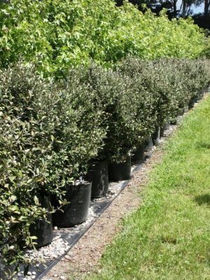

**Price:** $15.00

**Max height of mature tree**: 2m

* **Growth Rate**:

**Description:**

Corokia x virgata 'Frosted Chocolate' is a hardy native shrub with fine elongated oval leaves that are green with silver underside changing to bronze in winter. In early summer the plant produces small yellow flowers followed by small red berries. The Corokia x virgata 'Frosted Chocolate' has a fast growth rate and can grow up to 2m in height (after 10 years).

**Conditions of Place to be planted:**

* Sun: Full Sun
* Drainage: Any soil

**Maintenance Requirements:**

Hedging & Screens Wall-side Borders Drought Resistant Low Maintenance Coastal Cottage & Informal Garden Mediterranean Climate Plants. No pruning is required and generally pests and diseases free.

Hardwood Tree

# Willow Oak Tree

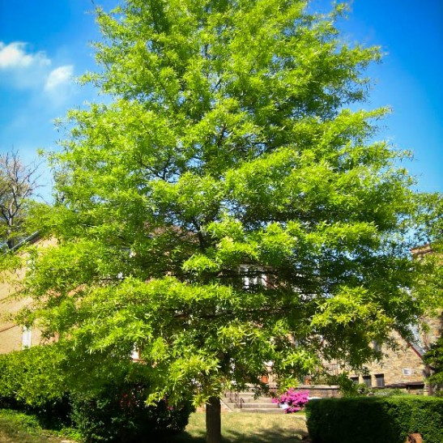

**Price:** $43.50 for 5 ft

**Max height of mature tree**: 40 ~ 75 ft

* **Growth Rate**:

**Description:**

This is a tree that thrives in moist to wet soils and is often found flourishing alongside water courses, hence swamp chestnut. It’s a tree that offers many textures and colors throughout the year with its delicate willow-like leaves that display beautiful autumnal shades in fall, deep green foliage in summer and light green leaves in spring. It is ideally suited as a shade tree, but also offers a rich food source for a wide range of birds that will flock to your garden to eat its tiny and abundant acorns. Between February and May it displays small delicate flowers and soft, hairy pendulous catkins with the size and density of the tree appealing to many small animals like grackles, flickers and flying squirrels. A fast-growing and impressive tree, it is perfect for that touch of grandness along avenues and gracing the lawns and gardens of large residences. **Conditions of Place to be planted:**

* Sun: Full Sun
* Drainage: Average

**Maintenance Requirements:**

The hardy nature of this tree means **it is suited to many different areas, from well drained moist loams to poor drainage clays**. That means it can thrive in various different soil environments but it does show a preference to medium wet, well drained soils in full sun. This said, Willow Oak adapts very well and can be equally at home in partial shade. It is also **considered generally tolerant of urban pollution** which expands the planting opportunities of this tree greatly. As is the case with all sizeable trees, consideration must be given to the proximity of houses, paths and roads when planting as ill thought out placement can cause future problems when roots and structures come to battle it out for space. Tree roots can be very persistent in laying claim to the space they require.

# Summer Red Maple

**Price:** $69.50

**Max height of mature tree**: 35 ~ 40 ft

* **Growth Rate**:

**Description:**

he Summer Red™ Maple is a wonderful shade tree, with an ever-changing display of purple-red leaves all season. In spring it is completely covered in glossy, deep-red new leaves, and in summer the new leaves on every branch are burgundy red, while the older leaves become a rich dark green. Then in fall your tree will turn beautiful shades of glowing yellow. Why settled for plain green when you can have colors like this? It grows quickly into a beautiful upright shade tree, reaching 40 feet or more in time, with a spread of around 25 feet across. Plant it on a lawn as a superb shade tree, or as a richly-colored avenue along a driveway or property line. Plant it in the background of a larger garden as a focal point

**Conditions of Place to be planted:**

* Sun: Full Sun
* Drainage: Moist, rich soils. Wet soils

**Maintenance Requirements:**

The hardy nature of this tree means **it is suited to many different areas, from well drained moist loams to poor drainage clays**. That means it can thrive in various different soil environments but it does show a preference to medium wet, well drained soils in full sun. This said, Willow Oak adapts very well and can be equally at home in partial shade. It is also **considered generally tolerant of urban pollution** which expands the planting opportunities of this tree greatly. As is the case with all sizeable trees, consideration must be given to the proximity of houses, paths and roads when planting as ill thought out placement can cause future problems when roots and structures come to battle it out for space. Tree roots can be very persistent in laying claim to the space they require

<https://www.thetreecenter.com/?s=native>